Burkina Faso

## Respect for rule of law (ROL) data

The data set shows the data on the respect of the rule of law for the country.

## # A tibble: 19 x 5  
## country iso3c date ruleOfLaw ruleOfLawCategory4   
## <chr> <chr> <dbl> <dbl> <chr>   
## 1 Burkina Faso BFA 1996 -0.933 ROL moderately disrespected  
## 2 Burkina Faso BFA 1998 -0.747 ROL moderately disrespected  
## 3 Burkina Faso BFA 2000 -0.620 ROL moderately disrespected  
## 4 Burkina Faso BFA 2002 -0.652 ROL moderately disrespected  
## 5 Burkina Faso BFA 2003 -0.540 ROL moderately disrespected  
## 6 Burkina Faso BFA 2004 -0.567 ROL moderately disrespected  
## 7 Burkina Faso BFA 2005 -0.520 ROL moderately disrespected  
## 8 Burkina Faso BFA 2006 -0.431 ROL moderately disrespected  
## 9 Burkina Faso BFA 2007 -0.399 ROL moderately disrespected  
## 10 Burkina Faso BFA 2008 -0.345 ROL moderately disrespected  
## 11 Burkina Faso BFA 2009 -0.207 ROL moderately disrespected  
## 12 Burkina Faso BFA 2010 -0.194 ROL moderately disrespected  
## 13 Burkina Faso BFA 2011 -0.359 ROL moderately disrespected  
## 14 Burkina Faso BFA 2012 -0.437 ROL moderately disrespected  
## 15 Burkina Faso BFA 2013 -0.530 ROL moderately disrespected  
## 16 Burkina Faso BFA 2014 -0.547 ROL moderately disrespected  
## 17 Burkina Faso BFA 2015 -0.527 ROL moderately disrespected  
## 18 Burkina Faso BFA 2016 -0.445 ROL moderately disrespected  
## 19 Burkina Faso BFA 2017 -0.405 ROL moderately disrespected

## Respect for rule of law (ROL) trend

The plot shows the trend of the respect for the rule of law for the country.

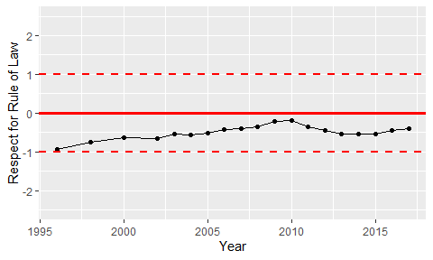

Trend of the Respect for the Rule of Law